

Technical Design Document (TDD)
Click to Pay

Date | 01/10/2025
Ideation ID (CA-PPM) | [IDE-XXXXXXXX]
Project OP (CA-PPM) | [BNSPRJOPXXXXXX or PRJ-XXXXXXXX]
Project Cost | xxxxxxx CAD
Country/Segment | Uruguay
Solution Architect | Esteban Buchner
Chief Architect | Matias Urroz
Delivery IT CIO/SVP | Mauro Novillo
IT SVP/CIO Sponsor | Luis Daniel Ivaldi Arellano
Business Sponsor | Paola Camejo
Business Unit | T&O
Data Office Intake Id | [For Data Initiatives Only]
The Technical Design Document (TDD) is essentially a clear and concise document that presents an end-to-end solution with the intention of providing stakeholders with clarity and visibility on how their business requirements will be met. Solution design can encompass a wide range of topics such as Architecture, Infrastructure, Data, Security, Operational Resiliency, Design, Development, Documentation, Deployment, Operations, and Support.
The primary objective of the Technical Design Document (TDD) is to list the systems which are in scope, provide context, document the data elements, dataflows and protection mechanisms, so that the Technical Design and Security of the solution can be evaluated prior to a change being performed.
The Technical Design Document (TDD) is a live document that refers to various phases of the project (during Architecture reviews, TRA process, OR process, Audit, etc.).
Refer to the Technical Design Document Guide to help complete this document to its entirety.

Table of content
1 Document Control 5
1.1 Document Revision & Change History 5
1.2 Sign-Off and Approvals 5
2 Initiative Overview 6
2.1 Initiative Objectives 6
2.2 Initiative Scope 6
2.3 Regulatory/Compliance and other Legal Requirements 6
2.4 Key Project Timelines & Initiatives Phases / Milestones 6
2.5 Risks/Challenges/Constraints 6
3 Solution Overview 6
3.1 Solution 6
EDF Gate 2 Conceptual Design
4 Business Architecture 7
4.1 Use Cases 7
4.2 Business Capabilities Model-Application Mapping 7
4.3 Business Resilience Requirements 7
5 Cloud Technology Capabilities 7
5.1 Cloud Adoption 7
6 Interfaces 8
6.1 System Context Diagram 8
6.1.1 Interfaces and Interfacing Applications 8
7 Conceptual Design 8
7.1 Conceptual Architecture Current 8
7.2 Conceptual Architecture Interim 8
7.3 Conceptual Architecture Target 8
8 Infrastructure Architecture 8
9 Key Architecture Decisions 8
EDF Gate 3 Logical Design
10 Logical Design 10
10.1 Logical Architecture 10
10.1.1 Logical Architecture Current 10
10.1.2 Logical Architecture Interim 10
10.1.3 Logical Architecture Target 10
11 Services, Patterns and Technology Standards 10
11.1 API’s & Event Services 10
11.1.1 BCS API’s and Events: 10
11.1.2 Non-BCS API and Events 10
11.2 Pattern Alignment 11
11.3 Technology Standard Stack 11
11.3.1 Monitoring Tools 11
11.3.1.1 Alerts 11
11.3.1.2 Dashboards 11
11.3.2 Infrastructure (SDN-Software Define Network) and Application Deployment Tool 12
12 Technology Debts 12
13 Operational Resiliency 12
13.1 High Availability 12
13.2 Business Continuity Planning (BCP) 13
13.3 Disaster recovery 13
13.4 Backup and Recovery Approach 13
13.5 Service Level Objectives /Service Level Indicators 13
13.6 Scalability and Peak exceeding volumes 14
13.7 NFR (Non-Functional Requirements) Validation Strategy 14
13.7.1 Ecosystem Descriptions 14
13.7.2 NFT (Non-Functional Test) Environment Capabilities 14
13.7.3 NFT (Non-Functional Test) Integration Approach 14
13.7.4 NFT (Non-Functional Test) Plans 14
13.7.5 Adherence to resilience policy 15
14 Infrastructure Design 15
14.1 Physical Diagram 15
14.1.1 Physical Diagrams – Current 15
14.1.2 Physical Diagrams - Interim 15
14.1.3 Physical Diagrams - Target 15
14.2 Infrastructure Details to support NFRs 15
15 Security Design 16
15.1 Component Diagram Technical & Security Details 16
15.2 Component Function 16
15.2.1 Interfaces and Sequence Diagram 16
15.3 Application Data and Process Flows 16
15.4 Authentication Design 16
15.5 Identity Lifecycle Management 17
15.6 Application Audit and Logging 17
15.7 Application Hardening & Configuration 17
15.8 Secure Software Development Life Cycle (SSDLC) 17
15.9 Authorization Model 18
15.10 Data Protection 18
15.11 Third-Party Processing 18
15.12 Infrastructure Security 19
15.12.1 Network and Security Design 19
15.12.2 Compute and Storage Infrastructure Auditing and Logging 19
15.13 Hardening & Configuration (Server, VM, and Containers) 19
15.14 Hardening & Configuration (Databases and Storage) 19
15.15 Cryptographic Security & Design 19
16 Data Design 20
16.1 Data Movement (Data Flows) 20
16.2 Logical Data Model 20
16.3 Data Structure 20
16.4 Data Physical Design 20
16.5 Technical Meta Data 20
16.6 Storage 21
16.7 Source to Target Mapping 21
16.8 Data Retention (Archival and Purging) 21
17 Application Architecture 21
17.1 System Components 21
17.1.1 Component Diagram 21
17.1.1.1 Frontend Description 22
17.1.1.2 Microservice Description 22
17.1.1.3 Middleware Description 22
17.1.1.4 Backend/Core Banking Description 22
17.1.1.5 Database Inventory and Design Artefacts 22
17.1.1.5.1 Database Description 22
17.1.1.5.2 Databases 22
17.1.1.5.3 Tables 23
17.1.1.5.4 Triggers 23
17.1.1.5.5 Views 23
17.1.1.5.6 Inventory of Stored Procedures 23
17.1.1.6 Report Design 23
17.1.1.7 Input / Output Files 23
17.2 Compute Detailed Design and Specifications 23

1 Document Control

Document Revision & Change History
Please track the document revision and change history in the table below.

Version # | Date | Revised by | Approved By | Summary / Description

Sign-Off and Approvals
Please list the sign-offs and approvals obtained as part of the TDD.

Document Version # | Approver  (Individual Name, Governance Body, Design Authority, etc.) | Approval ID | Approval Date | Sign-off evidence  (email)

Initiative Information
The following sections are common for all EDF Gates.

Initiative Overview

Arquitectura de C2P
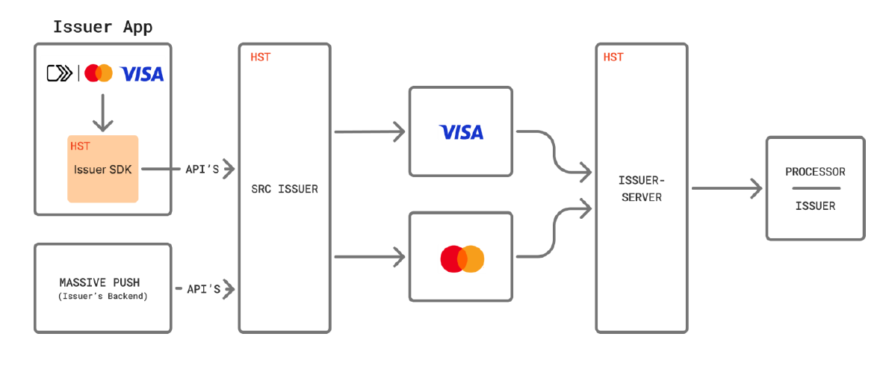

Initiative Objectives

Enrolamiento a billetera C2P

- Permitir enrolamiento masivo de todo el parque de tarjetas de crédito y debito de la bandera VISA, por un mandamiento de la marca
- Contemplar la actualización diaria del padrón, con las altas de nuevas tarjetas a los efecto de notificarlo a la billetera, dado que en el futuro todas las tarjeta emitidas deberán salir ya aprovisionadas en esta bóveda.

Bajas a billetera C2P

- Habilitar proceso de registración de solicitudes de bajas de clientes, tanto de perfiles (datos de la persona) como de sus productos (datos de la tarjeta)
- Procesar estas novedades contra la bóveda, a través de servicios de HST (APIs en Issuer Server)
- Conservar un log riguroso de todas estas operaciones para su seguimiento

Actualización de información en billetera C2P

- Permitir la actualización de datos del tarjeta habiente (perfil), como ser teléfono para notificaciones, dirección de correo electrónico, domicilio, etc.
- Permitir la actualización de datos de sus productos (tarjetas), como ser fecha de vencimiento, PAN, etc.

Initiative Scope
Inicialmente todos los clientes deberán ser informados a la bóveda (enrolamiento masivo a C2P)

Regulatory/Compliance and other Legal Requirements
Mandato VISA Nro.: AI14245 ​

Key Project Timelines & Initiatives Phases / Milestones
Fase 1:
- Enrolamiento masivo del parque de tarjetas Visa.
- Actualizaciones de datos en bóveda
Fase 2:
- Enrolamiento desde la APP.
- Autogestión de actualizaciones desde la APP
Fase 3:
- Emisión de tarjetas con logo de C2P

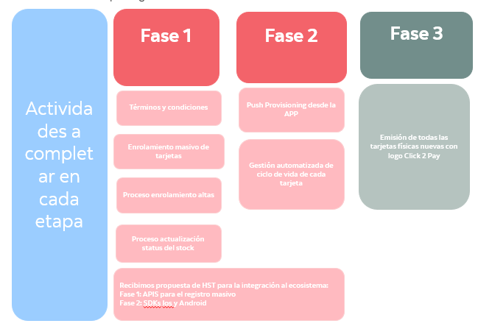

Risks/Challenges/Constraints
Este proyecto no presenta grandes dificultades tecnológicas, dado que se va a utilizar la misma arquitectura que ya se esta utilizando par billeteras (Apple Pay/Google Pay), sin necesidad de implementar nuevas comunicaciones con terceros
HST tiene hosteada (vendor hosted) la solución de Issuer Server, que será la encargada de hacer los aprovisionamientos en bóveda de la marca, a través de servicios de APIs
Por parte de Scotiabank, todo el desarrollo necesario para este intercambio, será desplegado en Anthos (private cloud)

Solution Overview

Solution

Fase 1 - Actualización de boveda de C2P

Flujo por el cual todas las tarjetas de crédito y debito del banco, están enroladas a esta billetera, para hacerle mas fácil y seguro la transaccionalidad a través de sitios de compras web, a los clientes.

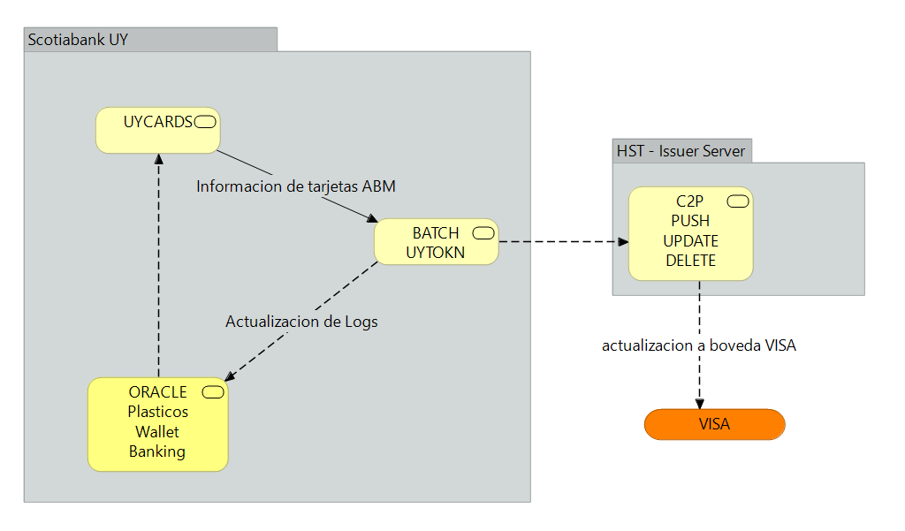

Name | Description
Initiate Bulk Job | This API allows to submit the cards profile information to the vault and receives a push receipt ticket for this job.  Sandbox: https://homolog-api-gateway.test-teste-prueba.com:9208/api/v3/bulkprovision/initiatebulkjob  POST  Production: https://issuer-bus.shieldedtransaction.com:9215/api/v3/ bulkprovision/initiatebulkjob  POST
Get Bulk Job Status | This API allows the issuers to query a bulk provision status for a given bulkPushReceiptID  Sandbox: https://homolog-api-gateway.test-teste-prueba.com:9208/api/v3/bulkprovision/getbulkjobstatus  POST  Production: https://issuer-bus.shieldedtransaction.com:9215/api/v3/ bulkprovision/getbulkjobstatus  POST

The following sections need to complete as part of EDF Gate-2
EDF Gate 2 – Conceptual Design

Business Architecture

Use Cases
- Provisionamiento masivo de tarjetas Visa
Permite la carga y procesamiento de grandes lotes de tarjetas Visa para su enrolamiento en Click To Pay.

Business Capabilities Model-Application Mapping

La iniciativa impacta principalmente en las siguientes capacidades y aplicaciones:
Capacidad: Provisionamiento masivo de tarjetas
Aplicación: Servicio de Bulk Provisioning responsable de recibir, validar y procesar los lotes de tarjetas para su enrolamiento en C2P.

Business Resilience Requirements
El proceso de provisionamiento masivo debe asegurar disponibilidad continua durante la carga y procesamiento de lotes, tolerancia a fallos con mecanismos de recuperación ante errores, integridad de datos para evitar duplicidades y un procesamiento seguro que cumpla con las políticas internas y el plan de continuidad del negocio (BCP).

Requirement | Value
RTO | #h
RPO | #h
Unavailability target | #h/ [measuring period - month, quarter or year]
Service Window | #h/ [measuring period - month, quarter or year]
Critical Times | #h/ [measuring period - month, quarter or year]
Critical User Journeys | User Journey Name
Geographic Spread of User / Customer Domiciles | Country List

Cloud Technology Capabilities

Cloud Adoption
La solución de provisionamiento masivo se desplegará en Anthos

System Context Diagram
[Provide a diagram to highlight the application interfacing environment showing the entities that interact with it]

Interfaces and Interfacing Applications
[Provide details in the table below of for each of the integration points and interfaces depicted in the integration diagram above. If the application interfaces Cloud Platforms, please specify the details in the diagram]

Interface | Purpose | Type | Protocol | Upstream/Downstream | Criticality

Conceptual Design

Conceptual Architecture Current
[Provide a current state diagram view of the application architecture at conceptual level]

Conceptual Architecture Interim
[If the solution will implement an Interim or “tactical” solution, different from the target/final or desired one, provide an interim state diagram view of the application architecture at conceptual level, if applicable]

Conceptual Architecture Target
[Provide a Target state diagram view of the application architecture at conceptual level]

Infrastructure Architecture

Key Architecture Decisions
[List the Architecture Decisions made]

Decision ID | Architecture Domain  (Highlight) | Decision Drivers | Options/Decision Considered | Rationale | Technical Debt | Impacts & Consequences
AD-001 | Business  Data  Application  Technology | Build vs Buy | In House Build  Buy Vendor Solution | Decisión corporativa, se usa HST issuer server que es el vendor seleccionado como producto aprobado en el catalogo de estandares | [Yes/No] | N/A
AD-002 | Business  Data  Application  Technology | Hosting Options | SaaS/Vendor Hosted  Scotia’s Public Cloud:[Specify Platform]______  Private Cloud  On Prem - Non-Private Cloud Offering | HST tiene hosteada (vendor hosted) la solución de issuer server.  Mientras que lo a desarrollar por Scotiabank será desplegado en Anthos (private cloud) | [Yes/No] | N/A

-

The following sections need to complete and review as part of EDF Gate-3
EDF Gate 3 – Logical Design

Logical Design

Logical Architecture

Logical Architecture Current
[Provide a current state diagram view of the application architecture at Logical or Low level.]

Logical Architecture Interim
[If the solution will implement an Interim or “tactical” solution, different from the target/final or desired one, provide an interim state diagram view of the application architecture at logical or low level, if applicable. Have EPM references where possible.]

Logical Architecture Target
[Provide a target state diagram view of the application architecture at logical or low level to show the end state architecture. Have EPM reference where possible.]

Services, Patterns and Technology Standards

API’s & Event Services

BCS API’s and Events:
List All the BCS API & Events used within this initiative in the table below: (BCS API & Events Catalogue)
Type  (Highlight) | API & Events Intake ID | BCS ID  (Mandatory for BCS) | Definition  Version  (If Applicable) | Bitbucket URL  (Contract) | Service Provider  (Area/Segment) | Type of Reuse  (If Applicable)  (Mandatory for Reusing) | External Facing  (highlight)
- Introducing  - Reusing | INT- | BCS- |  | POST /c2p/bulk-provision |  | - Contract  - Code  - Service Instance | - Yes  - No
- Introducing  - Reusing | INT- | BCS- |  | GET /c2p/bulk-job |  | - Contract  - Code  - Service Instance | - Yes  - No
- Introducing  - Reusing | INT- | BCS- |  |  |  | - Contract  - Code  - Service Instance | - Yes  - No

Non-BCS API and Events
List All the non-BCS API & Events used within this initiative in the table below:
Type  (Highlight) | API & Events Intake ID | Definition  Version  (If Applicable) | Bitbucket URL  (Contract) | Service Provider  (Area/Segment) | Type of Reuse  (If Applicable)  (Mandatory for Reusing) | External Facing  (highlight)
- Introducing  - Reusing | INT- |  |  |  | - Contract  - Code  - Service Instance | - Yes  - No

Pattern Alignment
List all applicable patterns leveraged for this initiative:(Patterns Catalogue)
Pattern Tag | Pattern Name | Version | Solution Alignment  (Highlight) | Rationale  (Mandatory for Patrial Alignment OR Deviation) | Related Architecture Decision  (Mandatory)
PAT_TLS_CERT_GCE |  |  | - Full Alignment  - Partial Alignment  - Deviation – Cannot be Used |  | [AD-001]  https://confluence.agile.bns/x/KJGtMw)

Technology Standard Stack
List All Technology Products used in the initiative: (Enterprise Standards Technology Catalogue)
Technology Capability | Product Name | Version | Vendor Name | Open Source | Disposition | Rationale (Required for Restricted/Retiring) | Related Architecture Decision  (Mandatory)
Orquestador de servicios. | Anthos UY (BHLF |  | Google | No | Aprobado |  | [AD-001]
Banking Core | Topaz (B8MD) |  | Topsystem | No | Aprobado |  | [AD-001]
Messaging Tool | Confluent Kafka  (BF8M) |  | Confluent | Yes | Aprobado |  | [AD-001]
Service/Application Languages | OpenJDK/OpenJRE (Adoptium) | LTS | Adoptium | Yes | Aprobado |  | [AD-001]
Framework/Tool | React | 18.x | Open source | Yes | Aprobado |  | [AD-001]
Relational Databases | Oracle (12) | 12c | Oracle | No | Aprobado |  | [AD-001]
Framework/Tool | Springboot | 3.5 | Open Source | Yes | Aprobado |  | [AD-001]
Web Tagging & Analytics | Google Firebase | SaaS | Google | No | Aprobado |  | [AD-001]
Encryption (FPE) | HST Card Tokenization | SaaS | HST Card Technology | No | Aprobado |  | [AD-001]

Monitoring Tools
[List and describe all the monitoring products or processes used to ensure availability and continuity of the application within this initiative]

Solution Component | Monitoring Category Type | Monitoring Tool(s) | Telemetry Types Used or Generated (Application Transaction Logs, Security Logs, Audit Logs, etc.) | Notification Delivery Mechanism | Support Team involved | Critical Dependencies
Dynatrace | Monitoring | Dynatrace | Server performance, Application Logs, Audit Metrics | Kubernates nodes and Closter, Disk, Cpu, Memory Network | SRE | Low

Alerts
[List all the alerts that have been created for this application with the description of the error.]

Alert Description | Telemetry Used | Threshold | Severity | Frequency | Monitoring Source/Tool | Support Team Involved
Monitor the resources associated with CPU | Open Telemery | >80 % | WARN | 5 min - 15 min | CPU | Customer Care, SRE and owner application
Monitor the resources associated with CPU | Open Telemery | >90% | CRITICAL | 5 min-15 min | CPU | Customer Care,SRE and owner application
Monitor the resources associated with Memory | Open Telemery | >80 % | WARN | 5 min-15 min | Memory | Customer Care,SRE and owner application
Monitor the resources associated with Memory | Open Telemery | >90 % | CRITICAL | 5 min-15 min | Memory | Customer Care,SRE and owner application
Monitor the resources associated with Disk | Open Telemery | >80 % | WARN | 5 min-15 min | Disk | Customer Care,SRE and owner application
Monitor the resources associated with Disk | Open Telemery | >90 % | CRITICAL | 5 min-15 min | Disk | Customer Care,SRE and owner application
Monitor the resources associated with Networking | Open Telemery | >80 % | WARN | 5 min-15 min | Networking | Customer Care,SRE and owner application
Monitor the resources associated with Networking | Open Telemery | >90 % | CRITICAL | 5 min-15 min | Networking | Customer Care,SRE and owner application

Dashboards
[Provide details to access application dashboards including URL’s and teams that support and consume the information. Please provide the dashboards for SLO, and where applicable on Infrastructure Health, Application Performance, Transaction Performance, Database Performance used for both reactive and proactive (includes trending and capacity management) monitoring. Other types can also be for Business-Critical functions and intelligence.]
Type | Team | URL
Dashboard | SRE, Customer Care , owener system | https://managed.dynatrace.bns/e/1d4cddc0-f19b-4c0b-86c2-26986066b75c/ui/dashboards?gtf=-2h&gf=all

Infrastructure (SDN-Software Define Network) and Application Deployment Tool

Deployment Tool | Description | Deployment Method | Rational  (Approved/ Restricted/ Prohibited)
Alfred | Alfred is the tool that orchestrates the automation of different processes that used to be performed manually, | automatic | Approved
Sonar | SonarQube is a self-managed, automatic code review tool that systematically helps you deliver clean code. | automatic | Approved
Checkmarx | Checkmarx focuses on static and dynamic code analysis issue identification, risk management, and regulatory compliance | automatic | Approved
Blackduck | Black Duck® software composition analysis (SCA) helps teams manage the security, quality, and license compliance risks that come from the use of open source and third-party code in applications and containers. | automatic | Approved
Jenkins | The leading open source automation server, Jenkins provides hundreds of plugins to support building, deploying and automating any project. | automatic | Approved
Artifactory | JFrog Artifactory is the single solution for housing and managing all the artifacts, binaries, packages, files, containers, and components for use throughout your software supply chain. | automatic | Approved

Technology Debts
[Specify in the table below if any technical debt is being introduced, continued, or retired.]
Debt Status  (Highlight) | Debt Type  (Highlight) | Component/  Application Name | EPM ID  (Mandatory) | Debt Details  (Mandatory) | Impact*  (Highlight) | Risk**  (Highlight) | Remediation Plan | Timeline  (YYYY-MM) – Mandatory *When will this be addressed | Related Architecture Decision
- Introducing  - Continuing  - Retiring | - Technology,  - Design  - Operational  - Currency  - Other |  |  |  | High,  Medium,  Low | High,  Medium,  Low |  |  | [AD-001]

Operational Resiliency

High Availability

Configuration (active-active, active-passive)
[Describe the type of HA pattern chosen to satisfy business non-functional requirements (e.g., active-active, active-passive, etc.), include diagrams to illustrate location of components and supporting infrastructure as well as facilities.]

Data Replication
[For each component requiring data redundancy for high availability, please complete the following table for Data Replication]

Data Store Type | Replication Pattern and methods used | Frequency of replication (real-time, scheduled)

Data Tooling
[Describe the tools utilized to provide the solution with HA capabilities.]
Name | Type | Version/Model | HA Role

Business Continuity Planning (BCP)
[In consultation with the business owner, specify the Business Continuity requirements for each business unit affected with timeframes (RPO/RTO) and describe how the solution has been designed to meet the business requirements]

EPM  Code | Application Name | RTO  (Recovery Time Objective) | RPO  (Recovery Point Objective) | Require RTO/RPO values update in EPM record? | Is a Third Party provided service? | Does it have geo-redundancy?  If yes, Indicate regions/Data center locations | BCP Plan  (If RTO >= 24h)
BJQT | UYCARDS | 6 hours | 2 days | No | No | Yes.  Se encuentran alojados en MX de acuerdo al siguiente profile:  Queretaro  Guadalajara | [Provide high-level BCP plan: Typically, 3 options:  Do Nothing: Accept the outage and wait until the system is back  Use alternate systems/applications: The business can operate using alternate IT systems  Manual process: The business can operate by running some manual processes. Once the system is back the transactions/operations could be recorded in the system]

Disaster recovery
Topaz: Se encuentra implementado en dos centros de datos:
PRD: IBM CANADA LIMITED - Data Centre/Infrastructure - DC On-Prem Guadalajara,Jalisco,Mexico
DR: IBM CANADA LIMITED - Data Centre/Infrastructure - Epigmenio González No. 2 Colonia Claustro del Parque David Rios, Queretaro, México

Anthos: Se encuentra implementado en dos datacenters (Queretaro y Guadalajara). Al quedar uno indisponibilizado, el otro continúa funcionando sin indisponibilidad de servicio.

Configuration and Data Replication
No tiene cambios a nivel de DR. Cada uno tiene el suyo propio.

Tooling
Es lo que ya está implementado para Anthos, Topaz y Confluent Kafka.

Name | Type | Version/Model | Role

Failover type
No hay modificaciones. Es lo que ya está contemplado en cada EPM

Backup and Recovery Approach
No hay modificaciones. Es lo que ya está contemplado en cada EPM

Description of platform storing the data | What characteristics of this platform need to be considered relevant to backup and restore | Description of Backup process (including elements such as how is the backup triggered, etc.) | Backup  (Frequency/ Full or Incremental / location / backup retention/ transaction log retention) | Description of Restore process and timing (including data transfer from backup environment to restore environment)
Oracle 19.18 EE on AIX (Database name: PRODT1) | IBM AIX 7.2 | Oracle RMAN (oraixprd02 crontab) | WEEKLY:Sat 6:55 UY / FULL / oraixprd02:/backup/rman/PRODT12 / 2 weeks | not needed, Oracle Dataguard is enabled for PRODT1

Service Level Objectives /Service Level Indicators
[Describe the details of the SLO’s and SLI’s.]
Journeys | SLO Description | Service Level Indicator (SLI) | SLI Description | Measurement Tool | Green | Yellow | Red

Scalability and Peak exceeding volumes
[Describe the forecasted volumes against NFT test capacities, approach to defend against demand exceeding availability, and scalability approach for each component.]
Tier | Forecasted Peak Volumes | Maximum Volume tested (NFT) | Approach for Volumes exceeding peak | Scalability Approach

NFR (Non-Functional Requirements) Validation Strategy
[Describe the details of the NFR Validation Strategy. Specify the details of Ecosystem Descriptions, NFT Environment Capabilities, NFT Integration Approach, NFT Plans, and Adherence to resilience policy.]

Ecosystem Descriptions
Ecosystem Name | Application Mnemonics | Business Function

NFT (Non-Functional Test) Environment Capabilities
[Describe the environment to be used to run Non-Functional tests (e.g. QA, Non-Prod, NFT). Include details of coverage discrepancies against its Production counterpart. Describe the environments to be used by each ecosystem for NFT testing.]

Ecosystem | Environment | Coverage Description

NFT (Non-Functional Test) Integration Approach
[Describe the NFT approach for each of the required integration with internal or external system.]
Ecosystem | Integration | NFR Test Approach

NFT (Non-Functional Test) Plans
[List Non-Functional tests required to ensure the solution ability to meet production requirements. Some NFT test are Performance, Capacity, Availability, Reliability, Integrity, Recovery, Maintainability. Describe the NFT test plan for each ecosystem that is required to properly ensure Non-Functional Requirements can be met, also if automation assets exist and can be reused during software development life cycle.]
Ecosystem | Required NFR Tests | Tooling | Automation | Acceptance Criteria | SDLC Reusability

Adherence to resilience policy
[Describe any limitation that prevents this solution for performing a 100% real Non-Functional test to adhere to the Enterprise Technology Availability and Resilience Policy and describe the limitations, mitigation, and residual technology risks for each ecosystem.]
Ecosystem | Limitation | Mitigation | Residual Resilience Risk

14 Infrastructure Design

14.1 Physical Diagram

14.1.1 Physical Diagrams – Current

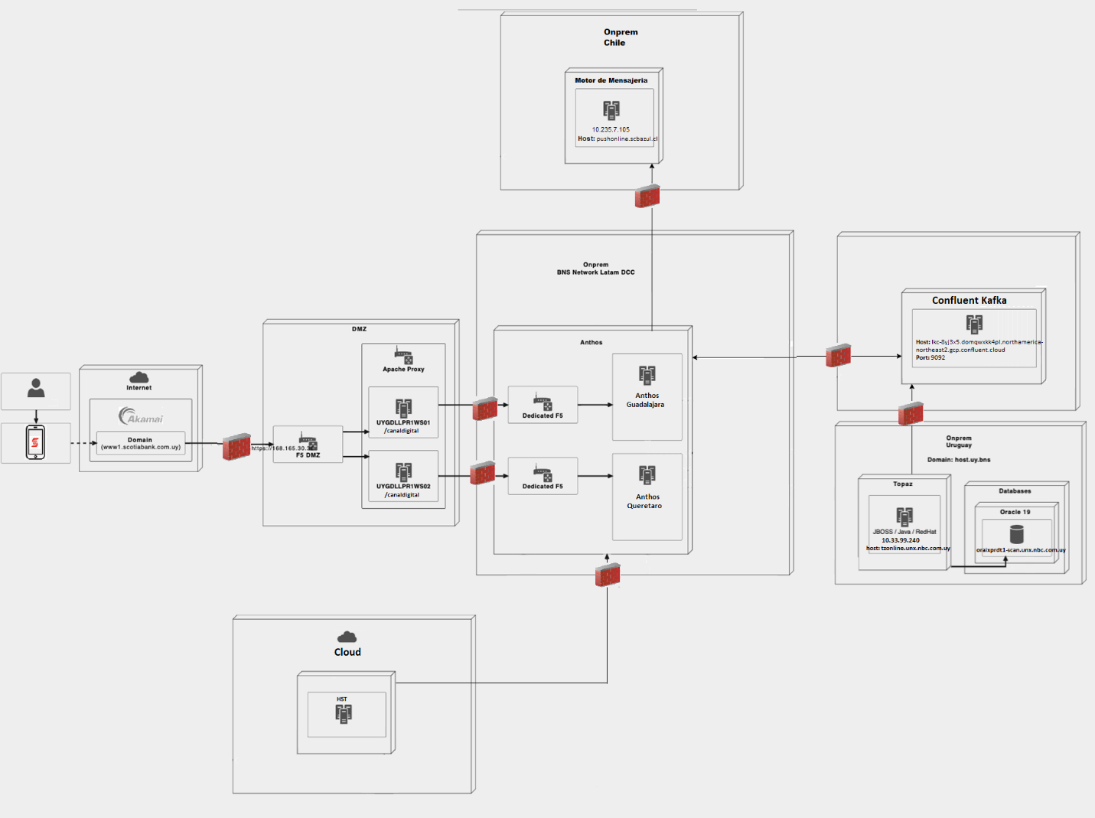

14.1.2. Physical Diagrams - Interim
N/A

Physical Diagrams – Target



14.2 Infrastructure Details to support NFRs
[Describe how the solution will be able to support all the Non-Functional Requirements (NFRs), in particular, but not exclusively, RTO and RPO. (Note: The information provided here need to match the records in EPM for the applications involved)]

15. Security Design

15.1 Component Diagram Technical & Security Details

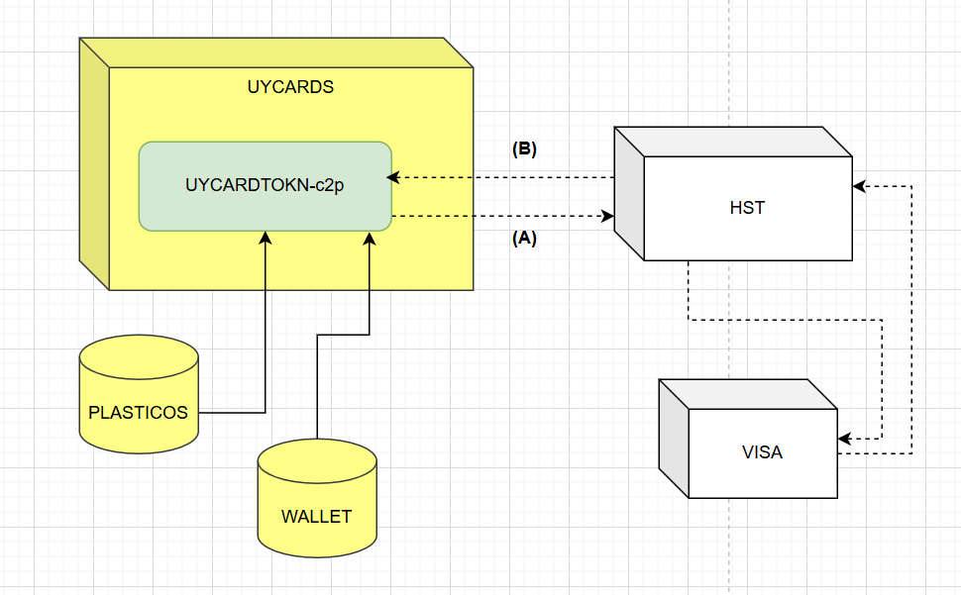

15.2 Component Function

15.2.1 Interfaces and Sequence Diagram

N/A

15.3 Application Data and Process Flows
[Complete below table to provide the viewpoint of the data and respective data flows observed for each component. Include data flow diagram(s)]

Data and Information Classifications - Integrity & Confidentiality
Information Component |  | Integrity |  |  |  |  |  |  | Confidentiality
 |  | Vital | Highly Valuable |  | Valuable |  | Limited Value |  | Registered Confidential |  | Confidential |  |  | Internal | Public
Scotia Mobile |  |  | X |  |  |  |  |  |  |  | X
Information Systems – Availability & Continuity
Information Component | Availability |  |  |  |  |  |  |  |  | Continuity
 | Critical |  |  | High |  | Medium |  | Low |  | Critical |  | High | Medium |  |  | Low
Scotia Mobile |  |  |  | X |  |  |  |  |  |  |  | X

15.4 Authentication Design
[Provide the Authentication Diagram (sequence diagram) and complete the table below]

Ref | Description | Protocol/Direction | Authentication | Store of Key or credential

Database Access Control:
Control# | Application/  Database | Details | Path | Environment (if applicable) | Access Type | Control Type
1 | UYCARDTOKN-c2p | Esquema: WALLET |  | PROD | Read,  Write | Basado en ROL
2 | UYCARDTOKN-c2p | Esquema: PLASTICO |  | PROD | Read,  Write | Basado en ROL

15.5. Identity Lifecycle Management
[Describe the identity lifecycle management process with logical diagrams, paragraphs and/or in table format]

Account Type | Description | Creation process / Approval Method | Deprovisioning processes
Database access | Cuanta para conectarse a la base de datos de notifications. | Service now

Application role definition:
[In the table below, Specify the role delimitations for each role. the term (Business Area*) references the banking function]

Role Name/  Group Name | Description | Application Role  Owner | Child Roles (Inheritance) | Group Membership | Business Area | Risk Level Categories | Directory/ Repository

Application Role Entitlement:
[In the below table, map application entitlements to the roles / groups listed in above table]
Entitlements | Entitlement Description | Role Name/ Group Name | Role Name/ Group Name | Role Name/ Group Name

Application Audit and Logging
[Describe how logging is enabled for Scotiabank developed applications, 3rd party developed applications or commercial off-the-shelf (cots) applications. In cases where your application/component(s) is/are hosted in cloud, please also describe how the audit data and logs will be accessed by Operations and other users while maintaining integrity]

Ya resuelto en todos los componentes que intervienen en la solución.
Este proyecto no realiza cambios respecto a los procesos ya existentes.
Service Name | Description of the process used | Local Server retention period | Conformation that logs are received by Security information and event management (SIEM) / Alerts are defined | Contains confidential, or registered confidential data Y/N

Application Hardening & Configuration
NA, Ya resuelto por, ctrl-m y Anthos. este proyecto no hace cambios en los procesos de cada uno.

Secure Software Development Life Cycle (SSDLC)
[Provide details relating to application/project level Secure SDLC]

Listado de ambientes:

Development | ANP- Creación y prueba unitaria de componentes
UAT | ANP - Prueba integrada de componentes
Producción | Ambiente Productivo

Repositorios:
https://bitbucket.agile.bns/projects/UYCARDTOKN/repos/c2p/browse

Proceso de aprobaciones:
Se sigue el flujo de autorizaciones en Service Now de GTS-Latam.

Proceso de testing:
Se realizan pruebas en los ambientes de QA y al cumplir con los casos definidos, se envía al ambiente de UAT donde se reprueba y se valida con los usuarios.

Deploy:
El deploy de los distintos componentes en producción lo realizan las torres de GTS Latam correspondientes a cada EPM.

Los cambios en la api en Anthos se promueven de forma automatizada utilizando contenedores. Los controles automáticos que se ejecutan son: Code Quality, Checkmark, Blackduck, SonarQube.

Para mas detalle referirise a Anthos SSDLC.

Authorization Model
[In the table below, capture a summary of the authentication between unique entities]

Identification entity (user, role, process, API, service) | Identity Issuance | Authentication  (Protocol, direction, TLS, Token, Basic Auth, etc.) | Authorization | Resource Request
UYCARDTOKN-c2p | Passport | OAuth2 | JWT Token and Scope | Resource API.

Data Protection
[Provide a diagram and describe all data protection mechanisms for each components storing/processing or transmitting Bank Data (on-prem, Scotiabank Private and/or Public Cloud, Third Party]

Component, Component #, Technology, | Bff-nextapp, | Bc-notification | Bc-subscription | Consumer-purchase | Bc-securikty | Bc-cards | Adapter-sms | Topaz | Uycards (prisma)
Data Classification | Confidential | Confidential | Confidential | Confidential | Confidential | Confidential | Confidential | Confidential | Confidential
Data Protection at Rest | N/A  No Persiste datos. | El acceso está protegido por la seguridad propia de la BD. | El acceso está protegido por la seguridad propia de la BD. | N/A  No Persiste datos. | N/A  No Persiste datos | N/A  No Persiste datos | N/A  No Persiste datos | N/A  No Persiste datos. | N/A  No Persiste datos.
Brief Security description
Data Protection in Transit (Yes/No, N/A) | Yes | Yes | Yes | Yes | Yes | Yes | Yes | Yes | Yes
Data Protection in Transit Description | HTTPS /TLS 1.2 | HTTPS /TLS 1.2 | HTTPS /TLS 1.2 | HTTPS /TLS 1.2 | HTTPS /TLS 1.2 | HTTPS /TLS 1.2 | HTTPS /TLS 1.2 | HTTPS /TLS 1.2 | HTTPS /TLS 1.2
Data Access User | No | No | No | No | No | No | No | No | No
Data protection technique used
Data Access Administrator  (Yes, No, N/A) | N/A | Yes, | Yes, | N/A | N/A | N/A | N/A | N/A | N/A
Logical Access Control Solution Used  (Yes, No, N/A), | N/A | Firecall (Centrify PAM Solution) | Firecall (Centrify PAM Solution) | N/A | N/A | N/A | N/A | N/A | N/A
System (API, Service Account, etc.) Access | N/A | Yes  Basado Rol y passsword | Yes  Basado Rol y passsword | N/A | N/A | N/A | N/A | N/A | N/A

Component | Secret | Almacenamiento
UYCARDTOKN-c2p | APPLE_PAY_KEY: Clave para encriptar tarjeta (Applepay).  PASSPORT_KEYSTORE: Passport keystore  PASSPORT_KEYSTORE_PASSWORD: Password passport keystore. | Hashicorp Vault

Third-Party Processing
[Provide third party systems involved in the table below]

Data and Information Classifications - Integrity & Confidentiality
Information Component |  | Integrity |  |  |  |  |  | Confidentiality
 |  | Vital | Highly Valuable |  |  | Valuable | Limited Value | Registered Confidential |  | Confidential |  | Internal | Public
Hst |  |  | x |  |  |  |  | x
Information Systems – Availability & Continuity
Information Component | Availability |  |  |  |  |  |  |  | Continuity
 | Critical |  |  | High | Medium |  | Low |  | Critical |  | High | Medium |  | Low
Hst |  |  |  | x |  |  |  |  |  |  | x

Infrastructure Security

Network and Security Design
[Provide network level diagram(s) to show all network components such as the following if applicable: (IP addresses must be shown) and complete the table below]

Connection # | Source | Destination | Ports | Comments
1 | 168.165.208.67  168.165.208.68  168.165.202.39  168.165.202.37  168.165.208.0/24  168.165.202.0/24 | 10.237.7.105 | 443 | Conexion desde Anthos hacia HST.
[Provide a description of the infrastructure, (e.g. sites, instances, technologies, high-availability, local load balancing, and global load balancing. (cross-site) redundancy, etc.)]

[Provide a configuration diagram]

Compute and Storage Infrastructure Auditing and Logging
[Describe how logging is enabled for compute or storage infrastructure components]

Hardening & Configuration (Server, VM, and Containers)
[Provide details for all compute services (VMs, Containers, services, serverless etc). Indicate hardening and security configuration baselines that is in place]

Anthos (BHLF)
Documentación obtenida del TDD de Anthos https://confluence.agile.bns/x/_9gFMg
Server Hardening Baseline
GKE on-prem cluster nodes run on Virtual Machines (VMs) in a vSphere cluster, keeping clusters up to date is responsibility of those who manage them.
VM services will be hardened to full compliance with the Scotiabank hardening standards before deployment in any environment. In the event of provisioned VMs running operating system or base software for which there is no existing Scotiabank Security standard, the team will work with Scotiabank Security to ensure there is an acceptable level of hardening, based on the CIS standard.
- • CIS Kubernetes Benchmark
- • CIS GKE Benchmark
- • CIS VMware Benchmark
- • https://cloud.google.com/anthos/clusters/docs/on-prem/latest/concepts/cis-ubuntu-benchmark?hl=es-419
- • https://cloud.google.com/anthos/clusters/docs/on-prem/latest/concepts/cis-benchmarks?hl=es-419

Container Hardening Baseline
Base container images will be curated from Google's managed base images and will include Ubuntu and scratch. Containers will undergo multiple levels of scanning to ensure the application, dependencies and the underlying OS are tested and secure.
For applications deployment in the platform, will be scanning through the pipeline via Sonar, Fortify and BlackDuck.
OS level CVE scanning will be done through Google Container Analysis. Container Analysis is a managed service from Google that supports scanning images with Alpine, Red-Hat, Debian, and Ubuntu bases. A scan is initiated when an image is pushed to Google Container Registry (GCR). The results of the scan will identify categorized CVEs with critical, high, medium, and low.

Hardening & Configuration (Databases and Storage)
[Describe the hardening processes]

Cryptographic Security & Design
Esta figura muestra un mecanismo propuesto para emitir certificados dinámicamente basados en certificados de objetos de ingreso, utilizando el administrador de certificados integrado de Kubernetes y HashiCorp Vault como autoridad de certificación.

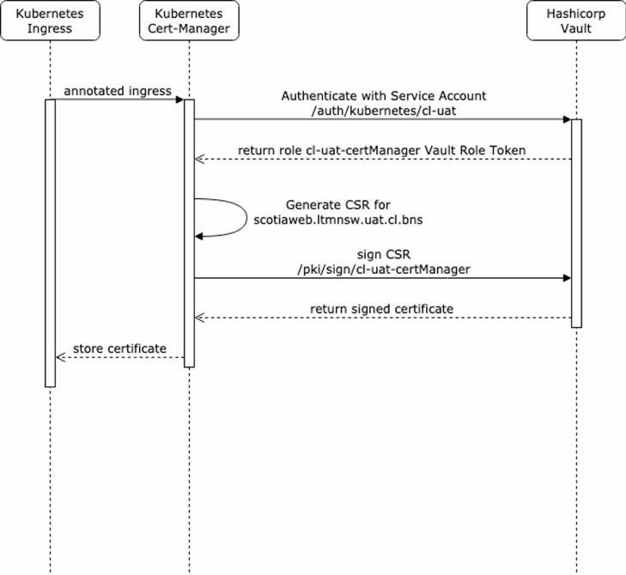
Para mas detalle consultar Anthos Technical Document Design

Key/Certificate Usage Table:
Key name, purpose, and owner | Key type and length  (bits) | Storage location | Key creation  Process and Distribution method | Key lifetime/ Rotation process | Key revocation and disposal process.
- Key name: bcs  - Purpose: Autenticar bc-notification con adapter-sms.  - Owner: Echerdt, Mauro | RS256, size 2048 bits | Vault key: /secret/data/uruguay/prd/nextapp/bc-notification | Se solicita mediante ticket a CKI. | Definido por CKI. | Se solicita al equipo de PASSPORT
- Key name: bcs  - Purpose: Autenticar bc-cards con UYCARDS.  - Owner: Echerdt, Mauro | RS256, size 2048 bits | Vault key: /secret/data/uruguay/prd/nextapp/bc-cards | Se solicita mediante ticket a CKI. | Definido por CKI. | Se solicita al equipo de PASSPORT
- Key name: bcs  - Purpose: Autenticar bff-nextapp con bc-subscription  - Owner: Echerdt, Mauro | RS256, size 2048 bits | Vault key: /secret/data/uruguay/prd/nextapp/bff-nextapp | Se solicita mediante ticket a CKI. | Definido por CKI. | Se solicita al equipo de PASSPORT
generado por HST.  Nos brindan la  Clave pública. | Algoritmo RS256 (RSA usando SHA-256, 256 bits). | El certificado se encuentra en HST la clave pública que nos brindan se almacena en Passport. | HST entrega al equipo de desarrollo la clave pública para que se realice el onboarding

TLS Certificate Cipher Suites:
Source | Destination | Protocol | Certificate Cipher Suites (List in server-preferred order)
(prisma) | 10.33.58.118  (Anthos Queretaro)  10.33.42.118  (Anthos Guadalajara) | HTTPS | TLS 1.3, AES-256-GCM
10.33.98.0/24 10.33.97.0/24  10.33.98.0/24 10.33.105.0/24  10.33.106.0/24 10.33.196.38/32 10.33.200.38/32 | 10.127.159.3  10.127.159.2  10.127.159.4 | HTPPS | TLS 1.3, AES-256-GCM
HST | Anthos | HTTPS | TLS 1.3, AES-256-GCM
Anthos | UYCARD | HTTPS | TLS 1.3, AES-256-GCM

(*) Las conexiones entre servicios en Anthos se realiza mediante protocolo http, y comparten las mismas ips.

Data Design

Data Movement (Data Flows)
[Provide a diagram to capture the data flows with showing the entities they interact with. The flows should describe the data (at the appropriate level) that is being moved.]

Logical Data Model
[Provide a diagram to demonstrate the Data Model of the initiative]

Data Structure
[Provide details on Database Data structure (include data and technical metadata)]

Data Physical Design
[Provide a diagram that represent the totality of the Physical Model of the Data Repository. It can be partitioned by subsystems, modules, data components, etc.]

Physical Data Element (Include Database Column, Tables, Triggers & Views, File Field)
[Provide following information to describe the data elements: Column Name, Business Meaning and use of the field, list of valid values, what the data is used for/how it is used, how is it derived/captured, what is it not?]

Technical Meta Data
[Outline the data elements to be included in the physical schema. Each data element requires the following information below]

- Column Key
- Column Name
- Readable Column Name
- Column Description
- Fully Qualified Name
- Data Type Length Text
- Primary Key Indicate
- Unique Constraint Indicate
- Foreign Key Indicate
- Nullable Indicate
- Valid Values Text
- String Format Masking Desc
- Default Assigned Value Text

Storage
[Specify the data requirements for storing such as HDFS/Object Store, and alignment with a specific platform (ex: Azure SQL, Big Query, Blob (Gen2) etc.,) and justify why and how this storage(s) was chosen for this project]

Source to Target Mapping
[Provide column level mapping of the source to the target include all the transformation. Provide the system level lineage documents that shows the end-to-end process from source system to target system (known as a Data Asset). All Source and Target Data Assets to support a data initiative are required to register as Data Assets to provide the system level lineage overview]

Data Retention (Archival and Purging)
[Please provide descriptions of any regulatory or internal audit and control requirements for the retention of data, how long the data will be kept, the archival process including frequency of archiving, what periods of data reside in which storage and disposal (deletion) of data when it is no longer needed]

Data being Archived | Required Data Retention Period | Regulatory or audit party and/or policy defining the retention requirement | Storage and format utilized, and data time periods for each
Describe the scope of the data to be archived, this may be the operational database, generated reported values | How long the data must be kept, usually in years |  | Describe where data will be moved to meet the retention requirements balancing cost, access to the data and how to support expected audit and forensic requirements and include purging process.

Application Architecture

System Components

Component Diagram
[Complete the following table to identify the components and their brief descriptions. Also include a diagram to demonstrate the depict of the components, protocol, dependencies, location etc.]
Component Id | Type | Function | Dependencies | Protocol | Location

Frontend Description
[Provide the detailed description of the component X. Please use the following table to identify the components of Frontend]
Micro APP/ Canvas UI APP | Folder/Module | Component/Pages | Description

Microservice Description
[Provide the detailed description of the component X.
Please use the following table to identify the components of Microservice]
MS ID | Microservice Name | Type of Reuse | Microservice Provider (Country/Segment)

Middleware Description
[Provide the detailed description of the component X. Please use the following table to identify the components of Middleware]
Service ID | Service Name | Functionality

Backend/Core Banking Description
[Provide the detailed description of the component X. Please use the following table to identify the components of Backend/Core Banking]
Program name | Type | Functionality

Database Inventory and Design Artefacts
[Provide how database is defined and managed in the database management tools. These should serve both as technical documentation as well as implementation instructions (code)]

Database Description
[Describe the database and the relationship between the system’s data, description of data types, etc.]

Databases
[List the databases and schemas where the data will be stored (account for RDBMS and version)]

Tables
[List all the tables that impacted from this initiative]
Table Id | Description

Triggers
[List Triggers and Specifications]
Id | Name | Event | Description/Functionality

Views
[List of Views and attributes]
Id | Name | Description/Functionality | Schema

Inventory of Stored Procedures
[List of Stored Procedures of this initiative]
Id | Name | Description/Functionality | Output

Report Design
[List of Reports generating from this initiative]
Report Id | Description

Input / Output Files
[List of Files received or delivered by the System from / to another System generating from this initiative]
File Id/File Name | Description

Compute Detailed Design and Specifications
[In below table, list all the infrastructure components that will be added for this solution]
Physical Server List:
HOST | Serial # | Admin IP | Admin VLAN | Blade Chassis | Bay | IP HOST (IMM) | IP Vmotion | VLAN VMOTION
Hardware Server List:
HOST | HW Model | OS | CPU | RAM | HDD | Network | HBA
Storage:
DATASTORE | URL | SIZE | File System | Backend
Virtual Machines:
HOST | Data IP | Admin IP | OS | vCPUs | RAM | Disks
Network connectivity:
SOURCE |  | DESTINATION |  | Aggregate
Switch | Card/Port | Switch | Card/Port

